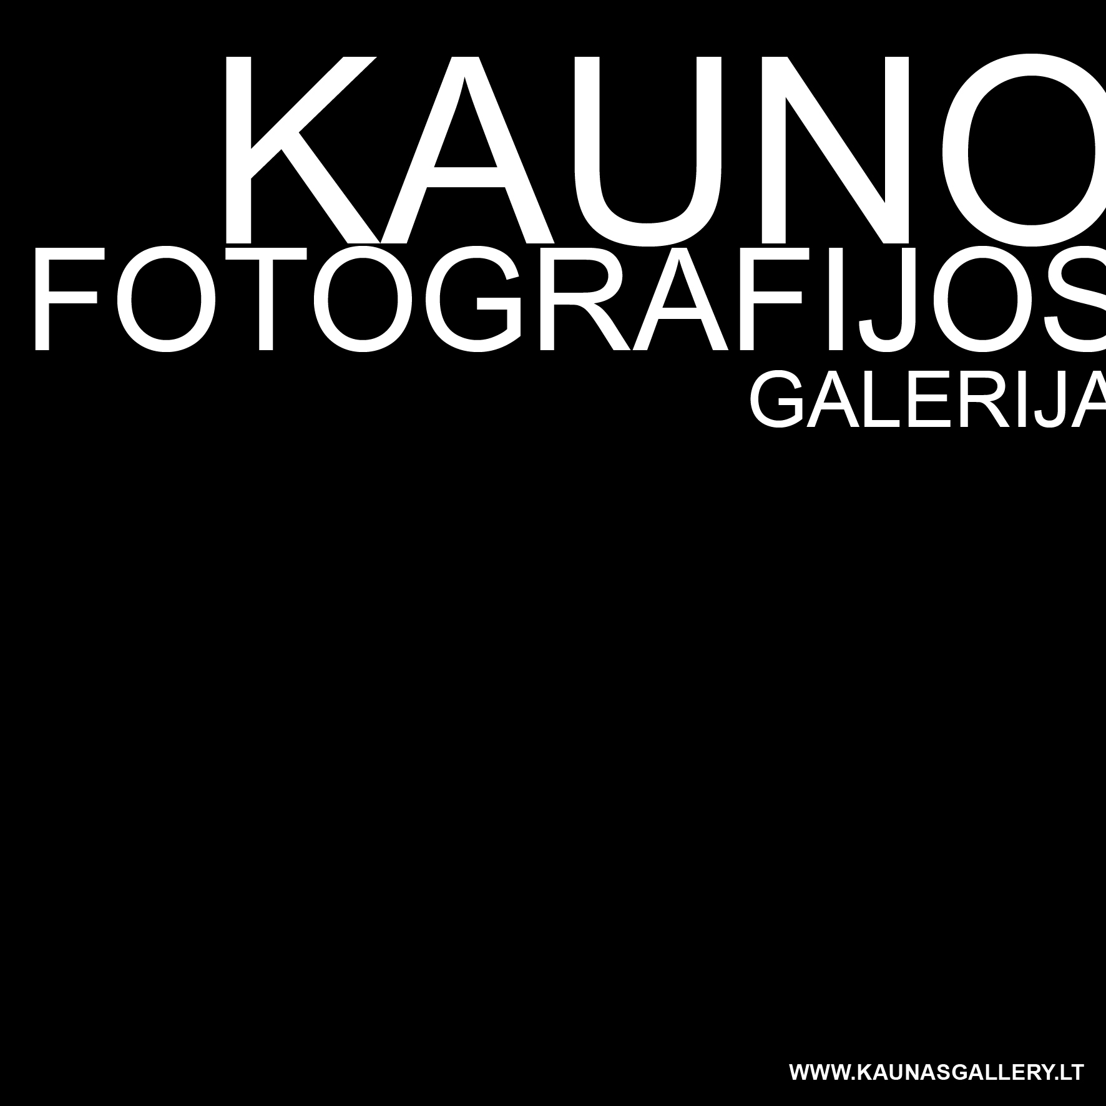 Kaunas Photography Gallery Residency

Application for Artist-in-Residence Programme
Residencies for March-December 2019
Family name:
First name:
Nationality:
Date of birth:
Address: | Street:  City:  Code:  Country:
Telephone number:

Email address:

Website:

Affiliated organization
(if any):
How did you find out about this programme?

Field of arts | Photography □ Art Research □ Curating □
Residency period from 2 to 6 weeks | 2019  March □ April □ May □ July □ August □ September □ October □ November □ December □
Language proficiency | English:  Fluent □ Advanced □ Intermediate □ Beginner □
Artist’s statement
(max. 500 words)
Activity/project proposal while in residency
How do you think your activity will contribute to the local area; or why do you want to come to this residency?
(max. 300 words)

Please do not forget to attach the following:
- CV including details of any professional training
- images in jpg format only (you can attach up to 20 images to your online application. Please bear in mind that your application should not exceed 15 MB. If you have larger files, please zip them or send via an online file sharing service (e.g. www.wetransfer.com)
- any relevant documentation, e.g. articles or papers about your work or exhibitions, publications, reviews, etc.
- please give the name and contact details of a referee who should have knowledge of your work in a professional capacity:
…………………………………………………………………………………………
…………………………………………………………………………………………..

Tel………………………………………….Email…………………………………….

Send your completed form with the relevant enclosures (images/ artist’s statement/ up-to-date CV/ supporting materials if any) to the address below before February 24, 2019.

EMAIL: gintare@kaunasgallery.lt (subject: residency application)

