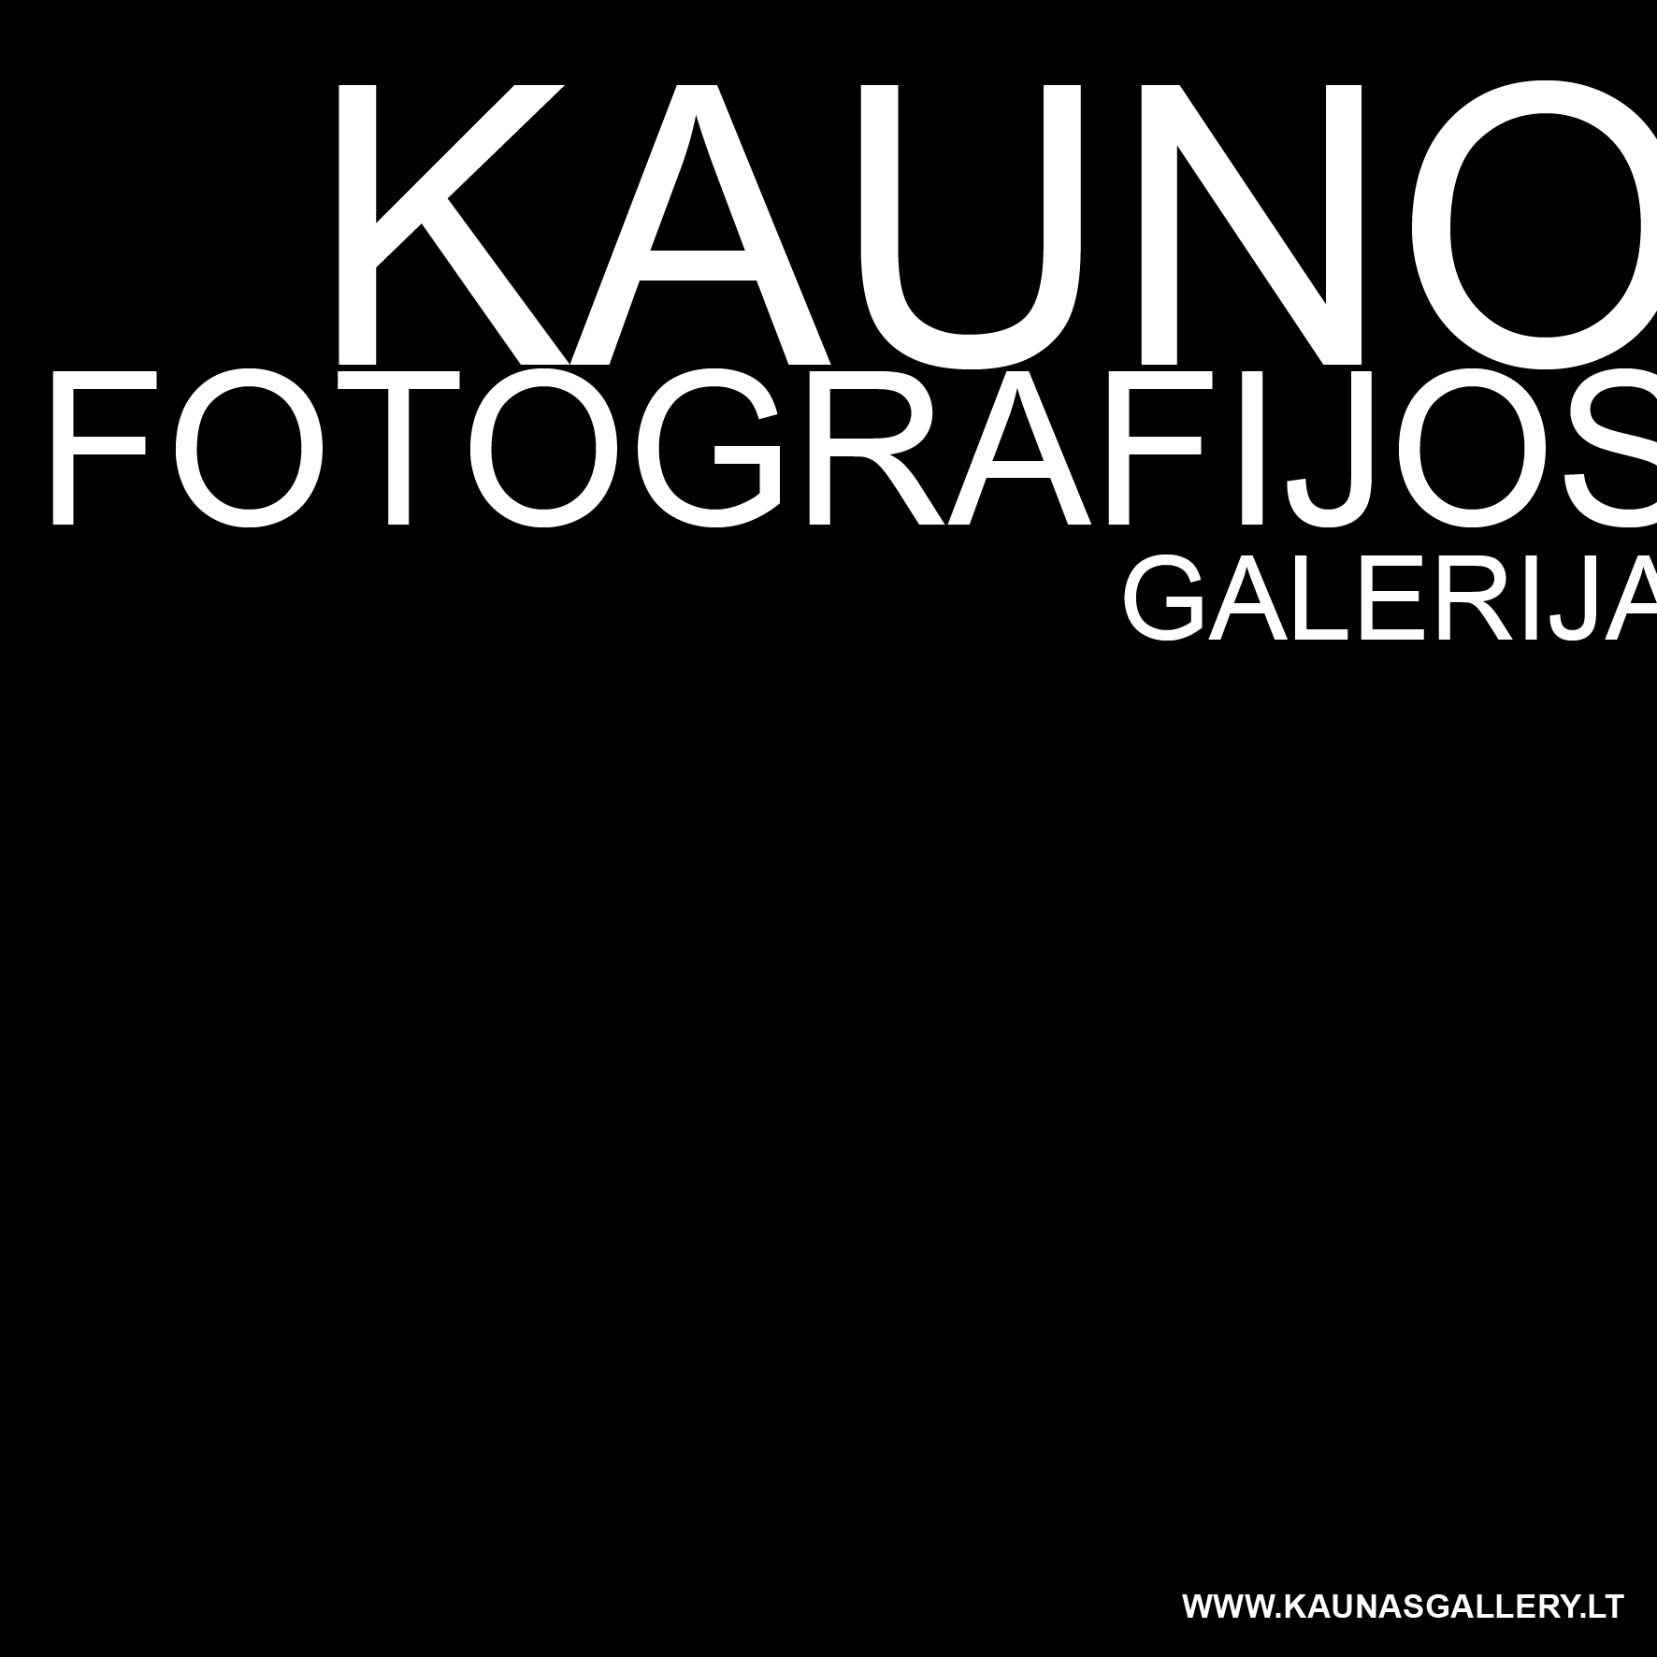 Kaunas Photography Gallery Residency

Application for Kaunas Photography Residency Program
Residencies for April–December 2024
Family name:
First name:
Nationality:
Date of birth:
Address: | Street:  City:  Code:  Country:
Telephone number:

Email address:

Website:

Affiliated organization
(if any):
How did you find out about this program?

Field of arts | Photography □ Art Research □ Curating □ Art History □  Art Criticism □
Residency period from 4 to 9 weeks | 2024  April □ May □ July □ August □ September □ October □ November □ December □
Language proficiency | English:  Fluent □ Advanced □ Intermediate □ Beginner □
Artist’s statement
(max. 500 words)
Activity/project proposal while in residency
How do you think your activity will contribute to the local area; or why do you want to come to this residency?
(max. 300 words)

Please do not forget to attach the following:
- CV including details of any professional training
- Supporting visual material
- Portfolio
- any relevant documentation, e.g. articles or papers about your work or exhibitions, publications, reviews, etc.
- please give the name and contact details of a referee who should have knowledge of your work in a professional capacity:
…………………………………………………………………………………………
…………………………………………………………………………………………..

Tel………………………………………….Email…………………………………….

Send your completed form with the relevant enclosures (images/ artist’s statement/ up-to-date CV/ supporting materials, if any) to the address below before 24 March 2024.

EMAIL: info@kaunasgallery.lt (subject: residency application)

